Afghans Fleeing for Their Lives
December 6th, 2021

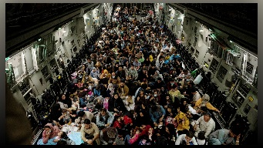
Pastor Scott Griswold, his wife Julie and their family lived in Cambodia over 10 years as missionaries and after moving back to the Houston Texas area, they continued the Lord’s work by helping refugees assimilate into their new environment, and demonstrate to them the love of Jesus.

Pastor Scott began, “Out of the blue I received a call from Afghanistan from a lady who quickly said, “I see from your website you have been helping Afghans. Can you get my family and me out, NOW?!” She went on to tell me that as a female journalist, she was in danger in her country and that her husband, because he’s a Christian, had been attacked and was in hiding.
“I told her we could add her name to the list of those we were trying to get out and to send me her family’s information. I was not prepared for the heart-breaking pictures she sent me. Someone tried to kidnap her two girls. They cried out for help and they were able to rescue them, but not before their little tongues were cut. It wrenched my heart to see such pain and to hear the mother’s pleas.
“The Lord has moved us to action and now we are raising funds to apply for humanitarian visas. Though there is a long backup with the US government, it is our best hope of getting them here, once we can get them out of the country. It is $575 per application and we are applying for 30 people. For a total amount of $17,250. Please help us get these refugees out of Afghanistan and into an environment of safety and peace. May God bless you all and keep you!

